**CIRCLE – ROBOTIC PARALLEL MANIPULATOR SYSTEM**

**Written by**

**Ayushman Choudhuri**

**Version 2.0**

**MARCH 2021**

**DOCUMENT VERSION LOG**

|  |  |  |  |
| --- | --- | --- | --- |
| **Document Version** | **Date of Release** | **Document Author** | **Addition Description** |
| 1.0 | 6-01-2021 | Ayushman Choudhuri | Robot Kinematics and Electronic Circuit Diagrams |
| 2.0 | 12-03-2021 | Ayushman Choudhuri | Robot Control System |
|  |  |  |  |
|  |  |  |  |

1. **INTRODUCTION**
2. **NOTATIONS AND SYMBOL DESCRIPTIONS**
3. **LIST OF FIGURES**
4. **ROBOT DESCRIPTION**

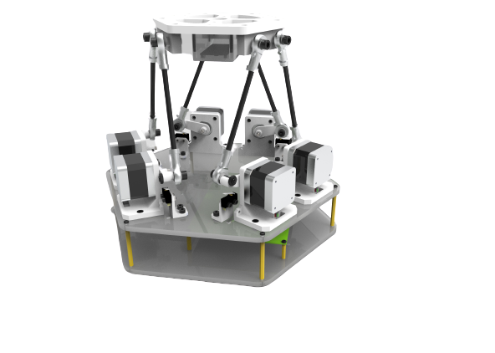

1. **ROBOT INVERSE KINEMATICS**

This section describes the inverse kinematics of the robot. Figure 1 depicts the kinematic model of the Circle robotic system. The figure shows the end effector plane, the base plane, and a linkage arm description. The end effector plane is defined by the points **{E1, E2, E3, E4, E5, E6}**. The base plane is defined by the **{B1, B2, B3, B4, B5, B6}**. The vector **BOE**is the translation vector between the base frame and the end-effector frame. The stepper motor arm length is described by **ai,** and the length of the link with an RSS configuration connecting the stepper motor arm to the end effector is **si**. The effective link length between the points **Ei** and **Bi** is defined by **li**. The base plane has a origin **O** at its center with **X**, **Y,** and **Z** as axes. The effector has an origin **O’** at its center and **X’**, **Y,’** **Z’** as axes.

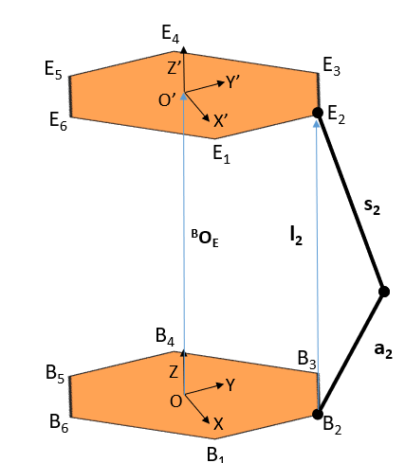

**Figure 1: Kinematic Diagram of the Circle Robot**

Each of the points **{B1, B2, B3, B4, B5, B6}** are the points of intersection of the stepper motor shaft axis and the motor rotation plane. Figure 2 shows the translated frame of reference **(X, Y, Z)** to a new motor frame of reference **(X’’, Y’’, Z’’)**. Vector **bi** with its components **{Δx, Δy, Δz}** is the translation vector between the two frames of reference. Figure 2 shows just one instance of this translation and can be generalized to all the motors.

In the motor frame of reference, the motor plane is the plane on which the motor arm rotates. Angle **β** is the angle by which the plane is offset in the motor frame of reference, and angle **α** is the offset angle of the motor arm from the origin position for the respective motor.

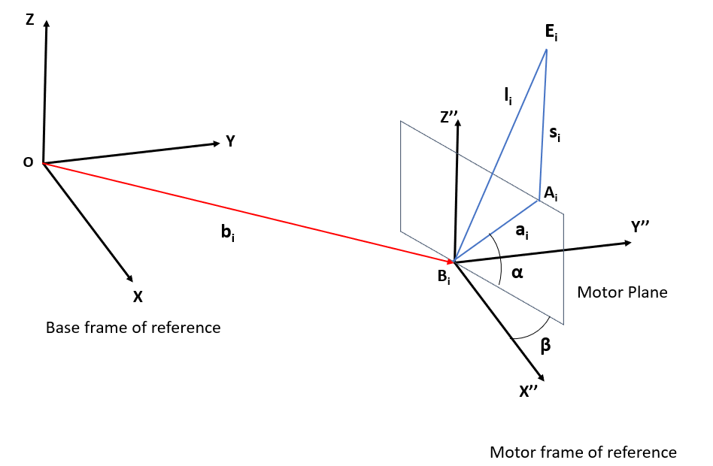

**Figure 2:** Description of the motor frame of reference with respect to the base frame origin

The points **Ai,** **Bi** and **Ei** have the following coordinate with respect to the base frame of reference as follows:

**Ai = [ Xa, Ya, Za] T**

**Bi = [ Xb, Yb, Zb] T**

**Ei = [ Xe, Ye, Ze] T**

From Figure 2, we can determine the coordinates for point **Ai** with respect to the base origin are:

1

Xa = ai.cosα.cosβ + Xb

2

Ya = ai.cosα.sinβ + Yb

3

Za = ai.sinα + Zb

From Pythagoras theorem, we have,

4

ai2 = (Xa – Xb)2 +(Ya – Yb)2 + (Za – Zb)2

5

li2 = (Xe – Xb)2 +(Ye – Yb)2 + (Ze – Zb)2

6

si2 = (Xe – Xa)2 +(Ye– Ya)2 + (Ze – Za)2

substituting equation 4 and 5 in 6, we get

7

li2 - (si2 – ai2) = 2(Xb2 + Yb2 + Zb2) + 2Xa(Xe- Xb) + 2Ya(Ye- Yb) + 2Za(Ze – Zb) – 2(XeXb + YeYb +ZeZb)

Now substituting values of Xa, Ya, Za from equation 1,2 and 3, in equation 7 we get

li2 - (si2 – ai2) = 2aisinα(Ze – Zb) +2aicosα(cosβ(Xe -Xb) + sinβ(Ye  - Yb ))

which is an equation of the form

L = Msinα + Ncosα

Using the trigonometric identity for sum of sine waves, we get

asinX + bcosX = csin(X+ɣ)

Where

c = sqrt (a2+b2) and tan ɣ = b/a

We thus have a sine function of α with a phase shift of δ

L = sqrt(M2 + N2) sin (α + δ) where δ = tan-1(N/M)

Thus

sin(α + δ) =[ L /(sqrt(M2 +N2)]

Thus

**α**i **= sin-1() – tan-1(**

8

Where

**L = l**i**2- (s**i**2-a**i**2)**

**M = 2a**i **(Ze -Zb)**

**N = 2a**i **(cosβ(Xe -Xb) + sinβ(Ye – Yb))**

Equation 8 can be used to calculate the required angles of each of the 6 motors using the link geometry parameters and the end effector coordinates as inputs.

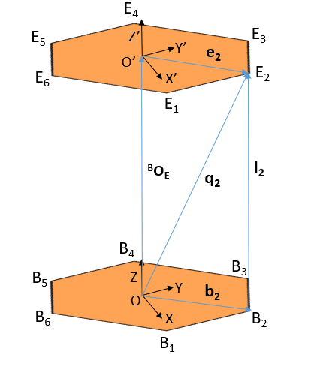

**Figure 3: Position vectors of motor B2 and End Effector point E2 with respect to base frame, motor frame and the end effector frame of reference**

From figure 3 , the position vector **q2** which describes the point E2 with respect to the base frame of reference.

9

q2 = BOE + BRE.e2

Here **BOE** is the translation vector between the base frame of reference and the end effector frame of reference. **BRE** is the

rotation matrix for the end effector frame with respect to the base frame of reference.

The vector **q2** can also be written as

10

q2 = b2 + l2

Hence, from equations 9 and 10 we can deduce

**l2 = BOE + BRE.e2 - b2**

This can be generalised to all the linkages as

11

**li = BOE + BRE.ei – bi**

The rotation matrix BRE for yaw $ψ$ , pitch $θ$ and Roll $φ$ turns out to be:

**BRE** =

Equation 11 can be used to calculate the effective link length of any of the linkages when the yaw pitch and roll angles of the end effector frame of reference is known with respect to the base frame of reference.

1. **SYSTEM ARCHITECTURE**

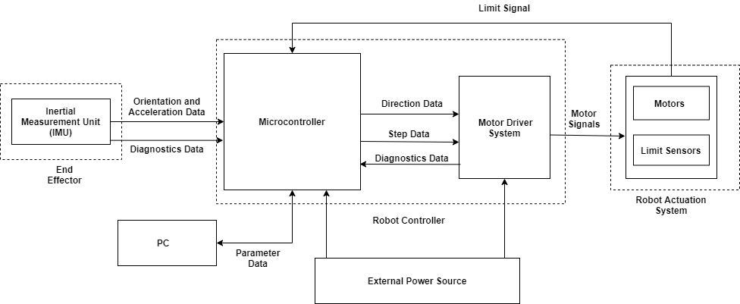

**Figure 4: Circle System Architecture**

* 1. **MICROCONTROLLER**
  2. **MOTOR DRIVER SYSTEM**
  3. **ROBOT ACTUATION SYSTEM**
  4. **INERTIAL MEASUREMENT UNIT**

1. **MECHANICAL DESIGN**
   1. **GENERAL DESCRIPTION**
   2. **ROBOT BASE**
   3. **ELECTRONICS BAY**
   4. **ROBOT LINKS**
   5. **END EFFECTOR DESIGN**
   6. **MANUFACTURING DETAILS**
2. **CONTROL SYSTEM DESIGN**
3. **SOFTWARE ARCHITECTURE**
4. **ELECTRONIC SCHEMATIC (V1)**

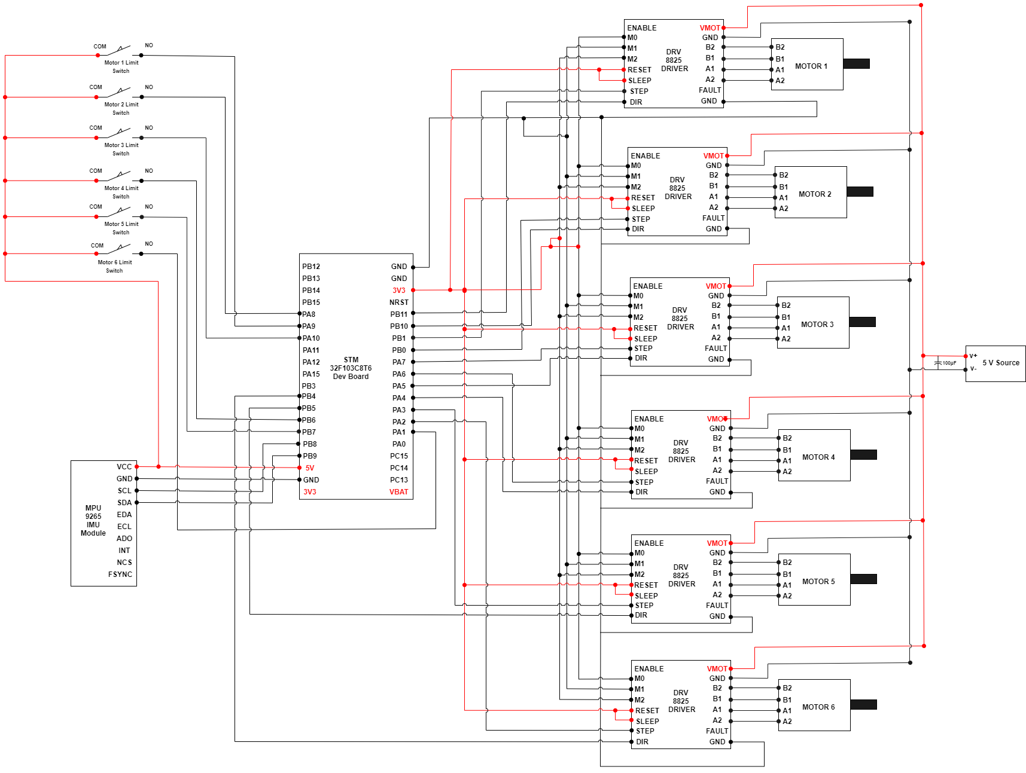

**Figure 5: Electronic Circuit Diagram V1**

1. **ROBOT PARAMETERS**
   1. **END EFFECTOR PARAMETERS**

Coordinates (in mm) of the end effector pivot point coordinates with respect to the end effector frame of reference.

E =

* 1. **BASE PARAMETERS**

Coordinates (in mm) of the base pivot point coordinates with respect to the base frame of reference.

B =

* 1. **HOME POSITION OFFSET PARAMETERS**
  2. **INERTIAL MEASUREMENT UNIT PARAMETERS (MPU 9250)**
  3. **STEPPER MOTOR DRIVER PARAMETERS (DRV8825)**

1. **REFERENCES**

**[1]** https://invensense.tdk.com/wp-content/uploads/2015/02/PS-MPU-9250A-01-v1.1.pdf

**[2]** https://cdn.sparkfun.com/assets/learn_tutorials/5/5/0/MPU-9250-Register-Map.pdf

**[3]**https://github.com/kriswiner/MPU9250/tree/master/Documents

**[4]**https://github.com/kriswiner/MPU9250/tree/master/STM32F401

**[5]**https://github.com/kriswiner/MPU9250

**[6]**https://www.ti.com/lit/ds/symlink/drv8825.pdf?ts=1615789139713&ref_url=https%253A%252F%252Fwww.google.com%252F

**[7]** https://www.pololu.com/product/2133

**[8]** https://www.youtube.com/watch?v=6IAkYpmA1DQ&ab_channel=HowToMechatronics